Table 1. General characteristics visceral leishmaniasis, Brazil, 2007-2024
Characteristic | < 30 days  N = 19 992¹ | 30-89 days  N = 13 576¹ | 90-119 days  N = 2 162¹ | ≥120 days  N = 2 879¹ | Overall  N = 38 609¹ | p-value²
Age years | 8 (2,34) | 21 (4,41) | 31 (14,46) | 33 (18,48) | 16 (3,39) | <0·0001
Gender |  |  |  |  |  | <0·0001
Female | 7 821 (39%) | 4 541 (33%) | 646 (30%) | 843 (29%) | 13 851 (36%)
Male | 12 168 (61%) | 9 035 (67%) | 1 516 (70%) | 2 036 (71%) | 24 755 (64%)
Education level |  |  |  |  |  | <0·0001
Incomplete elementary school | 1 739 (11%) | 1 453 (14%) | 257 (17%) | 404 (20%) | 3 853 (13%)
Complete elementary and incomplete middle school | 2 232 (14%) | 2 076 (20%) | 417 (28%) | 620 (31%) | 5 345 (18%)
Complete middle school and incomplete high school | 1 236 (7·8%) | 1 305 (13%) | 243 (16%) | 302 (15%) | 3 086 (10%)
Complete high school | 838 (5·3%) | 698 (6·7%) | 128 (8·5%) | 206 (10%) | 1 870 (6·3%)
Incomplete university | 66 (0·4%) | 53 (0·5%) | 15 (1·0%) | 19 (0·9%) | 153 (0·5%)
Complete university | 99 (0·6%) | 110 (1·1%) | 17 (1·1%) | 21 (1·0%) | 247 (0·8%)
N/A | 9 687 (61%) | 4 743 (45%) | 422 (28%) | 455 (22%) | 15 307 (51%)
Race/Color |  |  |  |  |  | <0·0001
Afro-descendants | 1 404 (7·2%) | 1 106 (8·3%) | 216 (10%) | 301 (11%) | 3 027 (8·0%)
Brown | 13 951 (71%) | 9 623 (72%) | 1 511 (71%) | 1 956 (69%) | 27 041 (71%)
Indigenous | 232 (1·2%) | 132 (1·0%) | 20 (0·9%) | 16 (0·6%) | 400 (1·1%)
Unknown | 937 (4·8%) | 547 (4·1%) | 92 (4·3%) | 120 (4·3%) | 1 696 (4·5%)
White | 2 954 (15%) | 1 818 (14%) | 279 (13%) | 393 (14%) | 5 444 (14%)
Yellow | 121 (0·6%) | 107 (0·8%) | 15 (0·7%) | 35 (1·2%) | 278 (0·7%)
Gestational age
1 Trimester | 8 (<0·1%) | 4 (<0·1%) | 1 (<0·1%) | 1 (<0·1%) | 14 (<0·1%)
2 Trimester | 27 (0·1%) | 13 (<0·1%) | 2 (<0·1%) | 2 (<0·1%) | 44 (0·1%)
3 Trimester | 20 (0·1%) | 7 (<0·1%) | 0 (0%) | 2 (<0·1%) | 29 (<0·1%)
N/A | 18 153 (91%) | 12 114 (89%) | 1 887 (87%) | 2 432 (84%) | 34 586 (90%)
No | 1 774 (8·9%) | 1 429 (11%) | 271 (13%) | 441 (15%) | 3 915 (10%)
Unknown | 10 (<0·1%) | 9 (<0·1%) | 1 (<0·1%) | 1 (<0·1%) | 21 (<0·1%)
Days symptoms to diagnosis | 13 (7,19) | 40 (31,61) | 95 (92,106) | 161 (131,210) | 27 (12,59) | <0·0001
Days symptoms to treatment | 14 (8,20) | 43 (34,62) | 97 (93,106) | 163 (135,211) | 28 (14,56) | <0·0001
¹Median (Q1,Q3); n (%)
²Kruskal-Wallis rank sum test; Pearson's Chi-squared test

Table 2. Setting and characteristic of treatment by categorized delay of treatment

Characteristic | < 30 days  N = 19 992¹ | 30-89 days  N = 13 576¹ | 90-119 days  N = 2 162¹ | ≥120 days  N = 2 879¹ | Overall  N = 38 609¹ | p-value²
Fever |  |  |  |  |  | <0·0001
No | 1 067 (5·3%) | 759 (5·6%) | 186 (8·6%) | 306 (11%) | 2 318 (6·0%)
Yes | 18 839 (94%) | 12 771 (94%) | 1 966 (91%) | 2 560 (89%) | 36 136 (94%)
Oedema |  |  |  |  |  | <0·0001
No | 14 729 (74%) | 9 741 (72%) | 1 535 (71%) | 1 915 (67%) | 27 920 (72%)
Yes | 4 543 (23%) | 3 397 (25%) | 552 (26%) | 860 (30%) | 9 352 (24%)
Bleeding |  |  |  |  |  | <0·0001
No | 17 398 (87%) | 11 596 (85%) | 1 762 (81%) | 2 280 (79%) | 33 036 (86%)
Yes | 1 701 (8·5%) | 1 434 (11%) | 303 (14%) | 473 (16%) | 3 911 (10%)
evolution |  |  |  |  |  | <0·0001
Cure | 15 590 (86%) | 9 837 (84%) | 1 520 (81%) | 1 974 (81%) | 28 921 (85%)
Death not VL | 291 (1·6%) | 218 (1·9%) | 48 (2·6%) | 55 (2·3%) | 612 (1·8%)
Death for VL | 1 129 (6·2%) | 760 (6·5%) | 156 (8·3%) | 218 (8·9%) | 2 263 (6·6%)
Neglect | 93 (0·5%) | 71 (0·6%) | 11 (0·6%) | 19 (0·8%) | 194 (0·6%)
Transferred | 980 (5·4%) | 796 (6·8%) | 135 (7·2%) | 176 (7·2%) | 2 087 (6·1%)
HIV status |  |  |  |  |  | <0·0001
No | 14 499 (73%) | 9 619 (71%) | 1 518 (70%) | 2 027 (70%) | 27 663 (72%)
Yes | 1 218 (6·1%) | 1 170 (8·6%) | 219 (10%) | 293 (10%) | 2 900 (7·5%)
Unknown | 4 275 (21%) | 2 787 (21%) | 425 (20%) | 559 (19%) | 8 046 (21%)
Treatment
Amphotericin B deoxycholate | 2 244 (11%) | 1 601 (12%) | 288 (13%) | 407 (14%) | 4 540 (12%)
Antimonial Pentavalent | 12 632 (63%) | 8 597 (63%) | 1 255 (58%) | 1 663 (58%) | 24 147 (63%)
Liposomal amphotericin B | 4 409 (22%) | 2 957 (22%) | 531 (25%) | 714 (25%) | 8 611 (22%)
Others | 663 (3·3%) | 395 (2·9%) | 84 (3·9%) | 91 (3·2%) | 1 233 (3·2%)
Pentamidine | 44 (0·2%) | 26 (0·2%) | 4 (0·2%) | 4 (0·1%) | 78 (0·2%)
¹n (%)
²Pearson's Chi-squared test

Figure 1. Delay distribution between symptoms onset to diagnosis and diagnosis to treatment
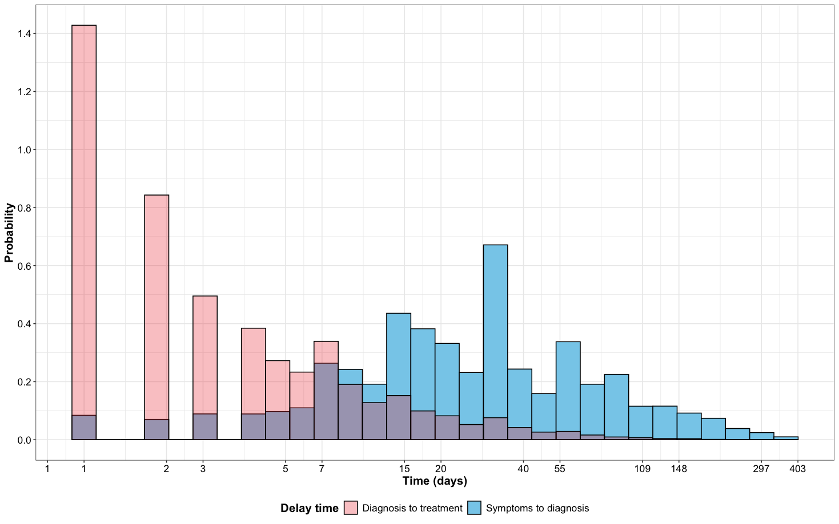

Figure 2. Delay distribution between symptoms onset to treatment
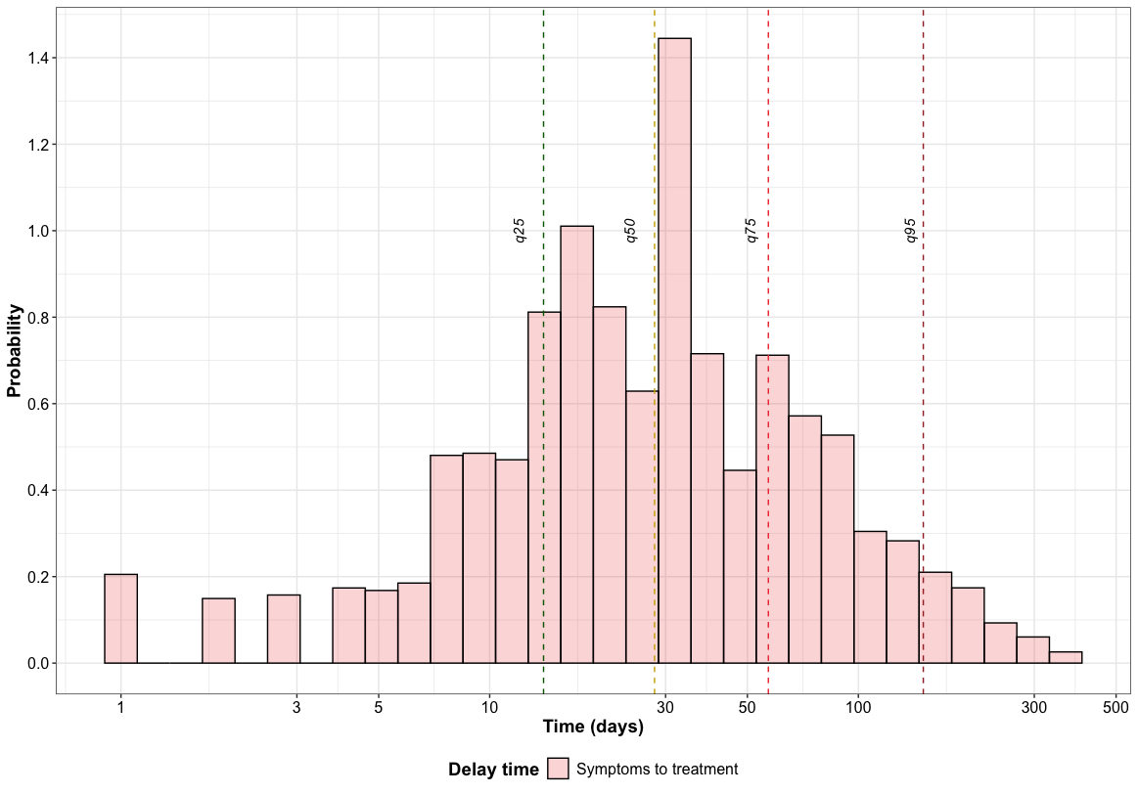

Figure 3. Population pyramid according with delay category between symptoms onset to treatment.
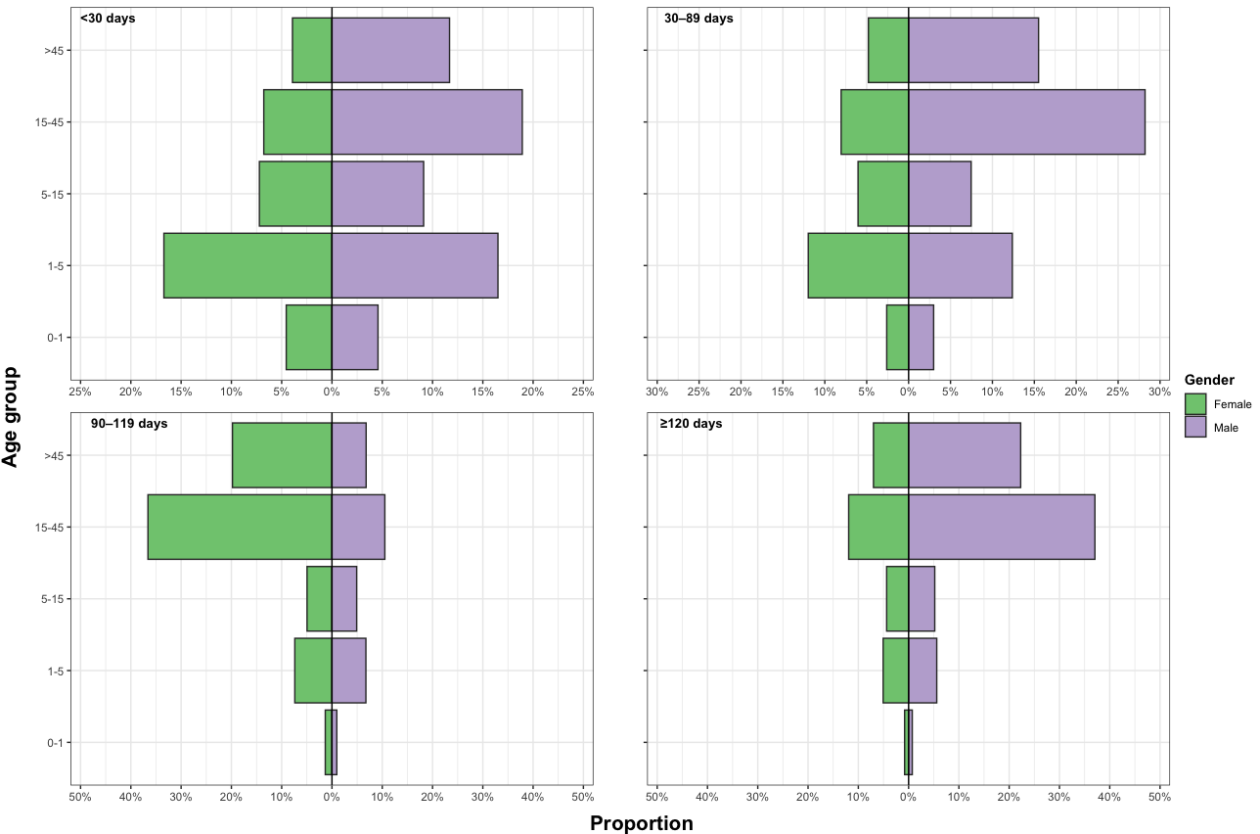

Figure 4.1. Distribution and relationship age according with delay between symptoms onset to treatment by gender.
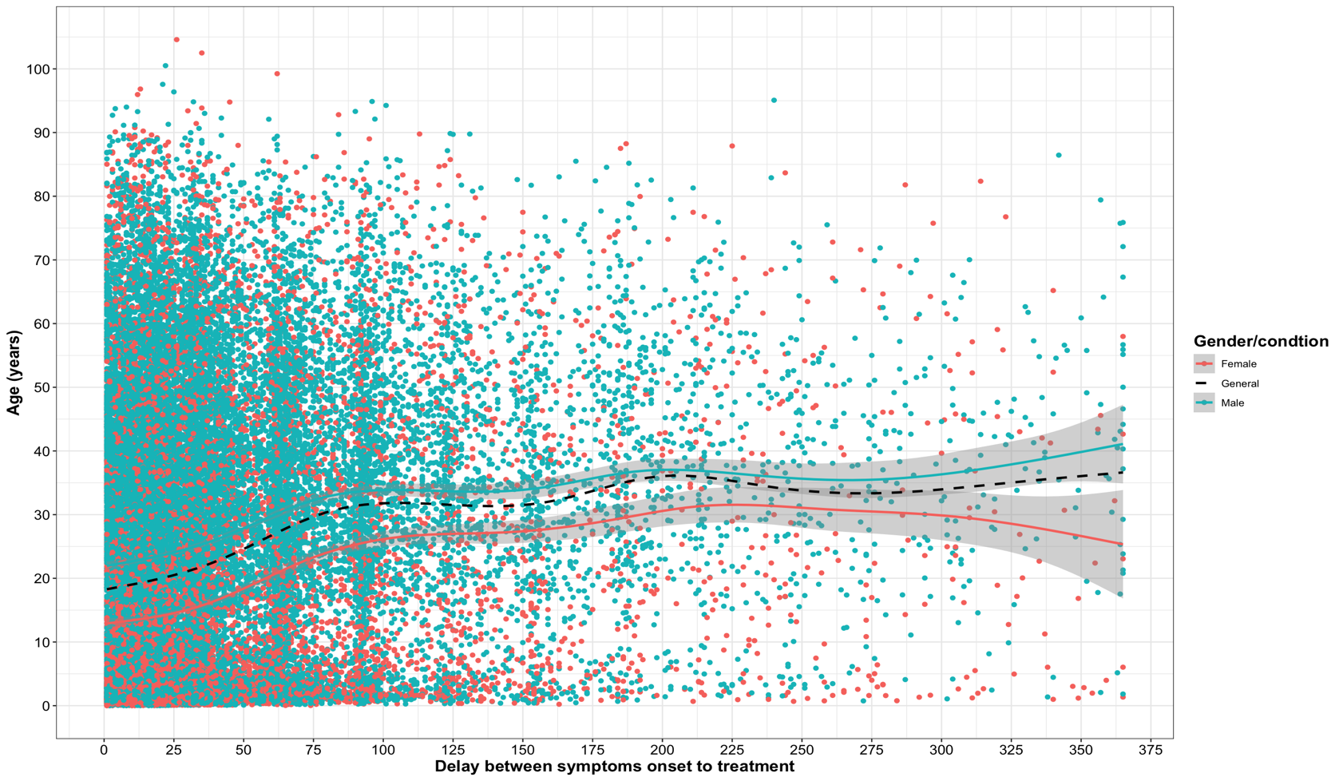

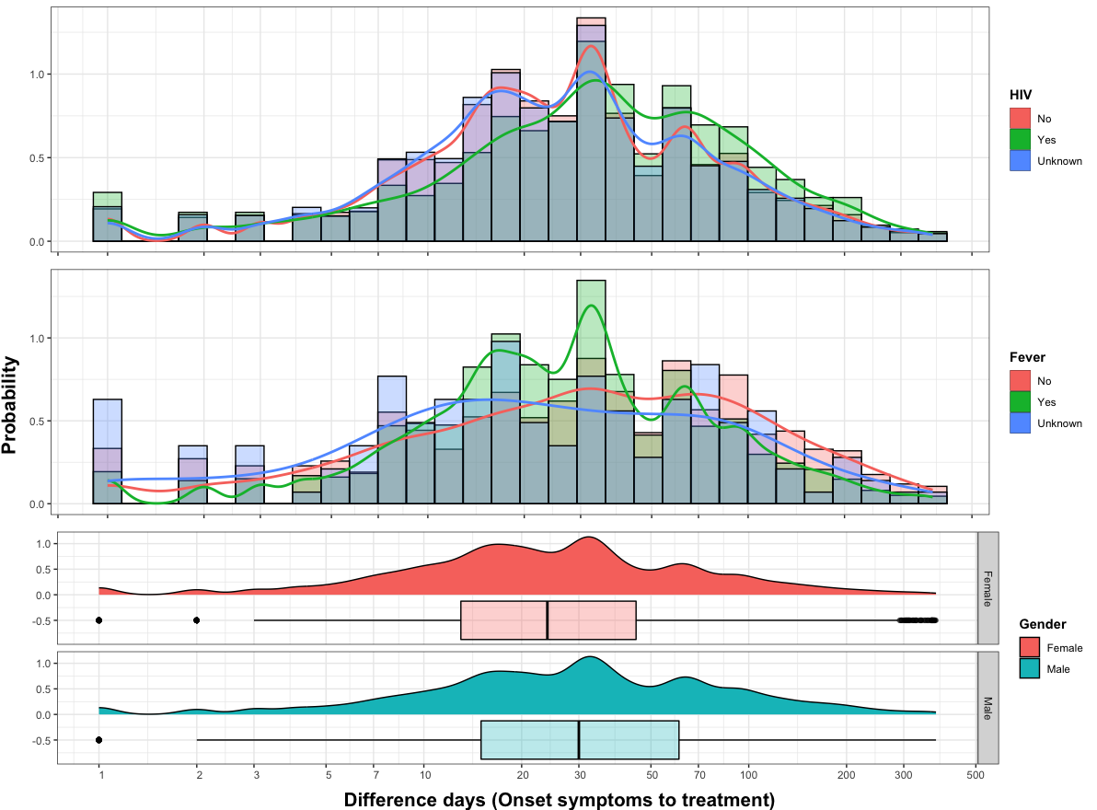
Figure 4. Delay distribution between symptoms onset to treatment

Figure 5. Delay distribution according with Federative states
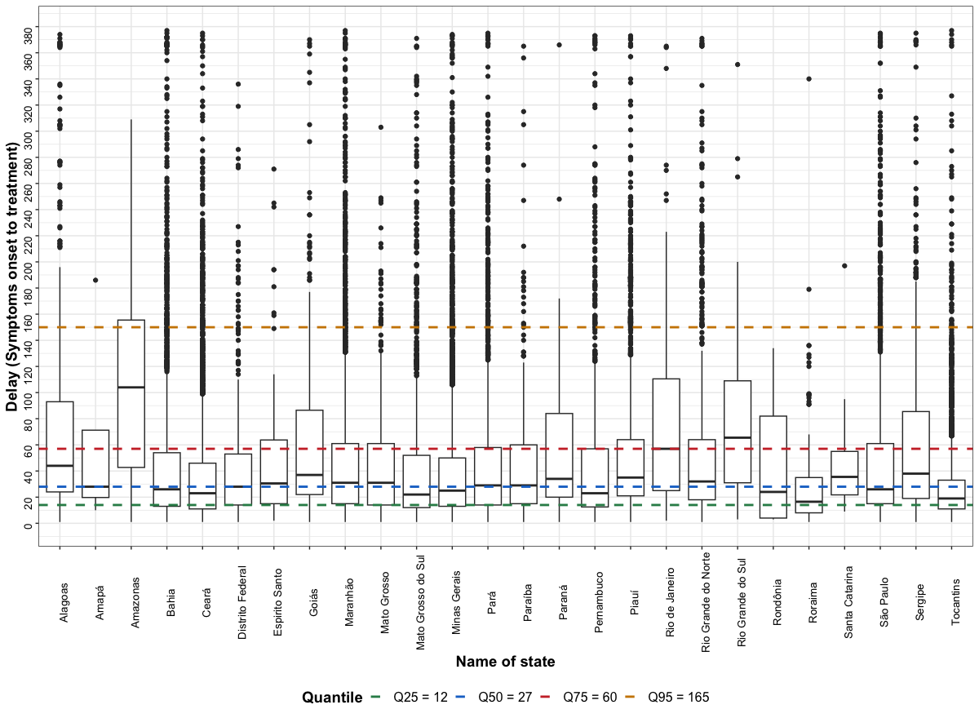

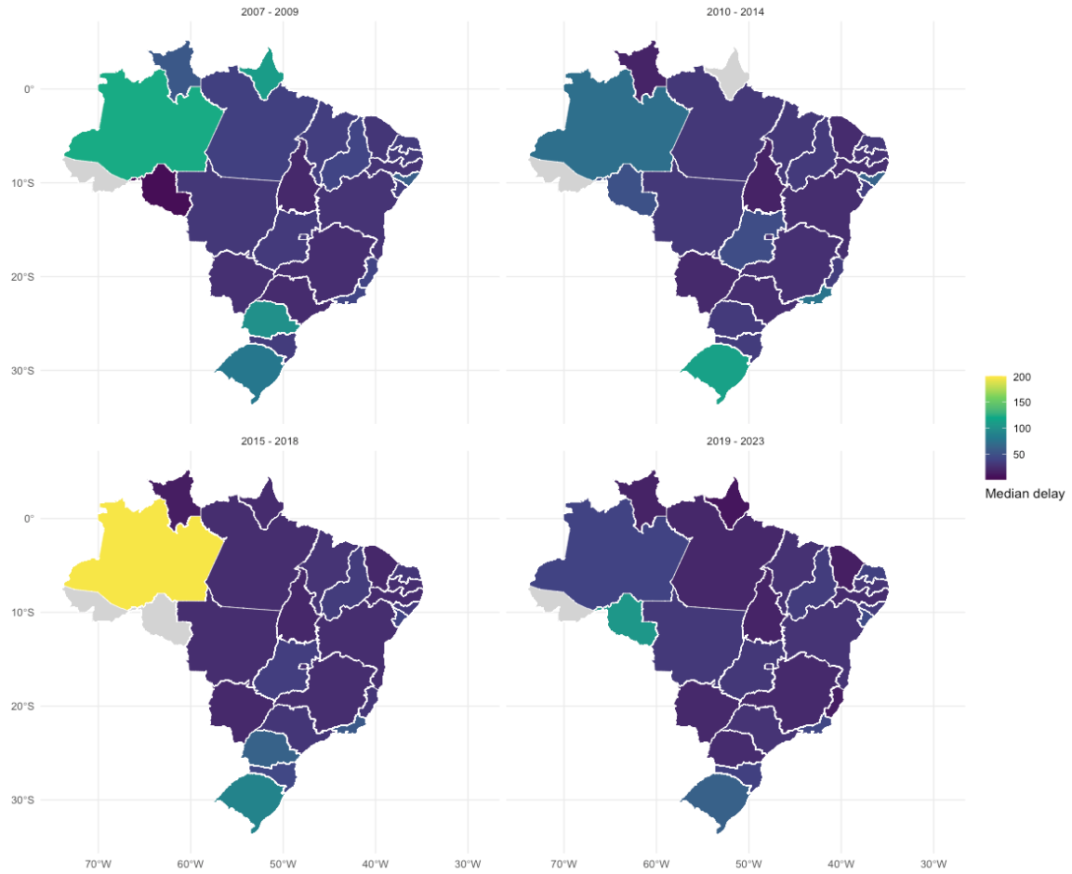

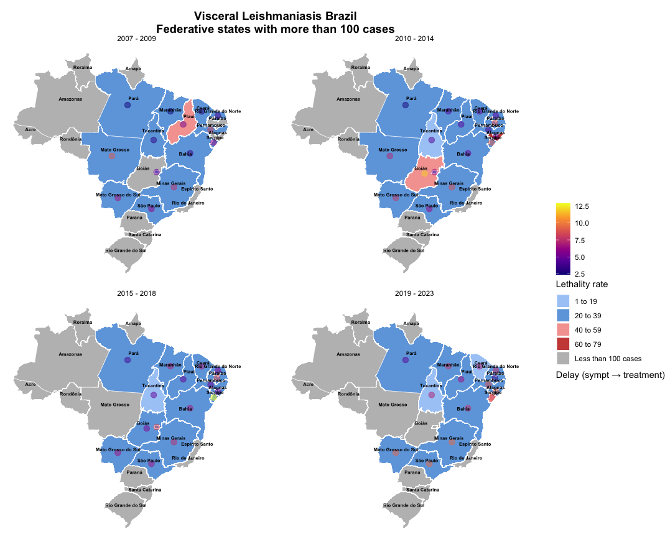

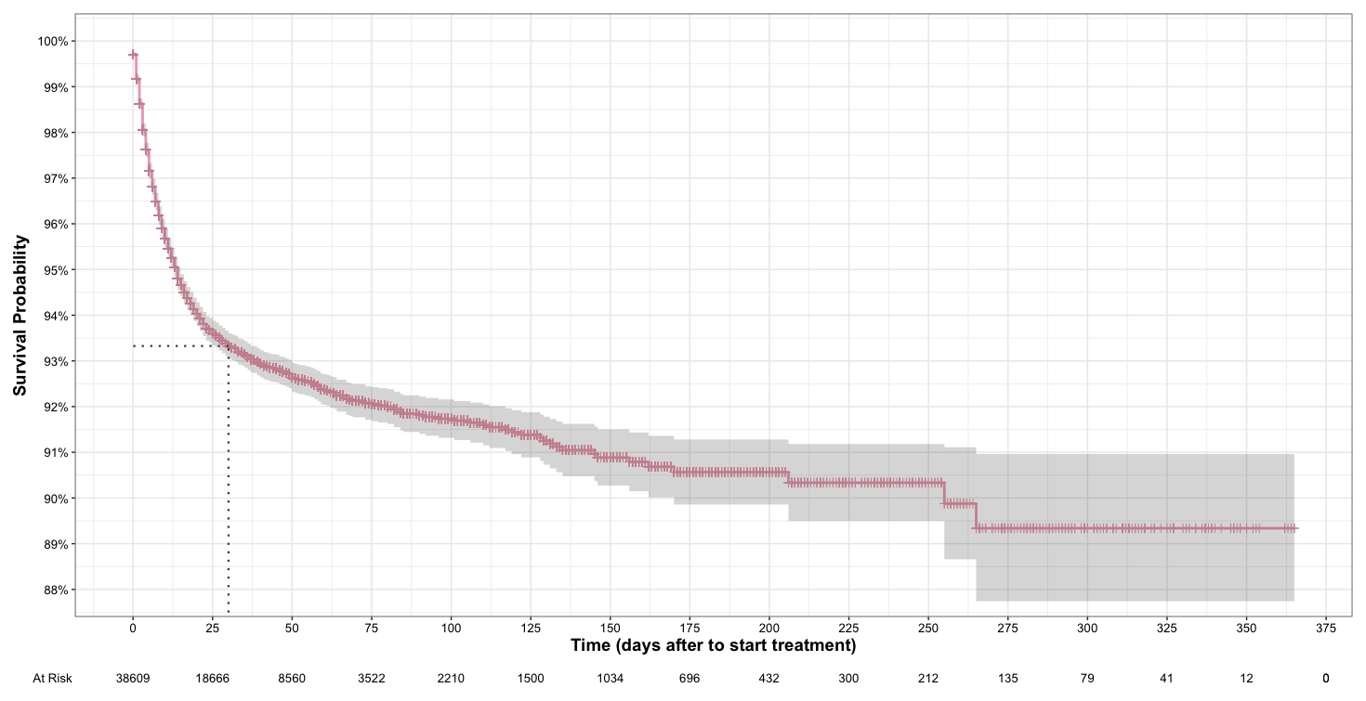

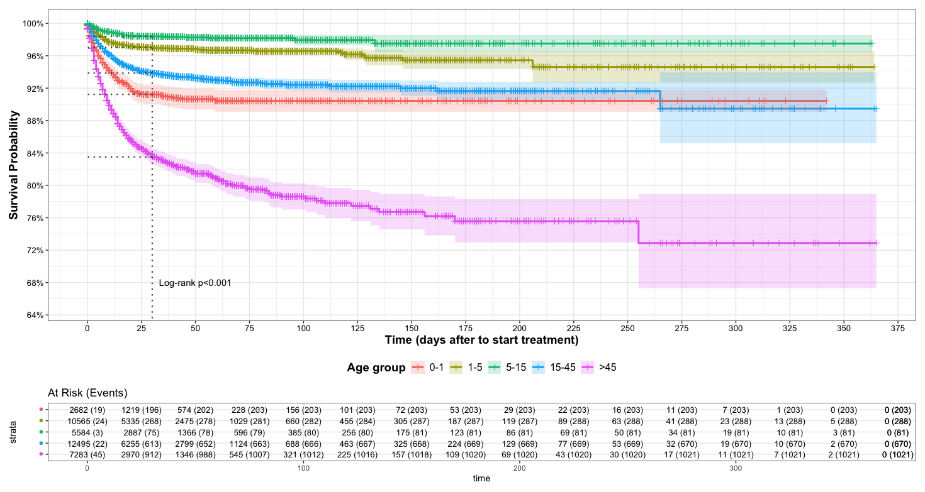

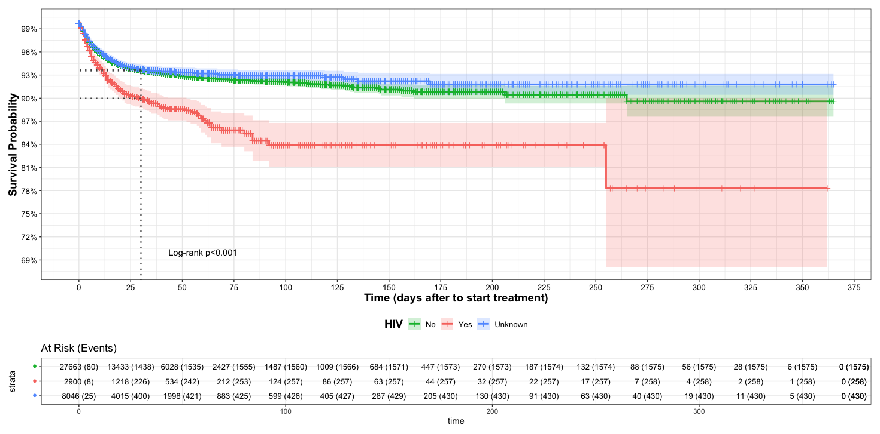

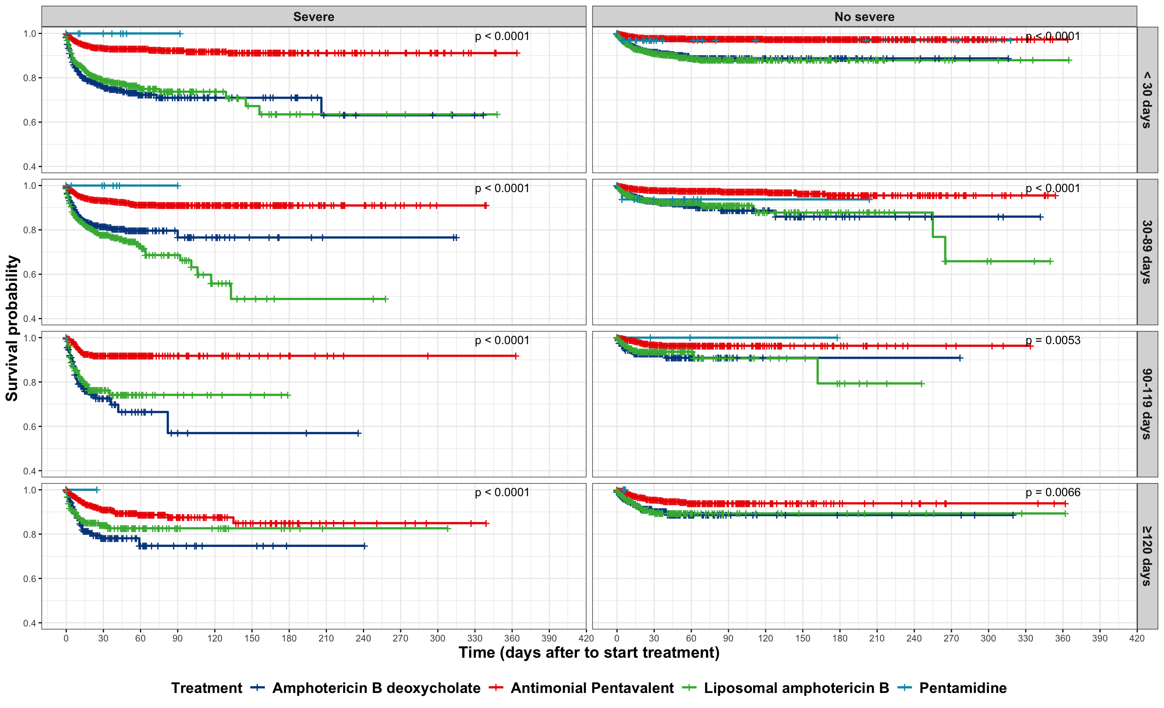

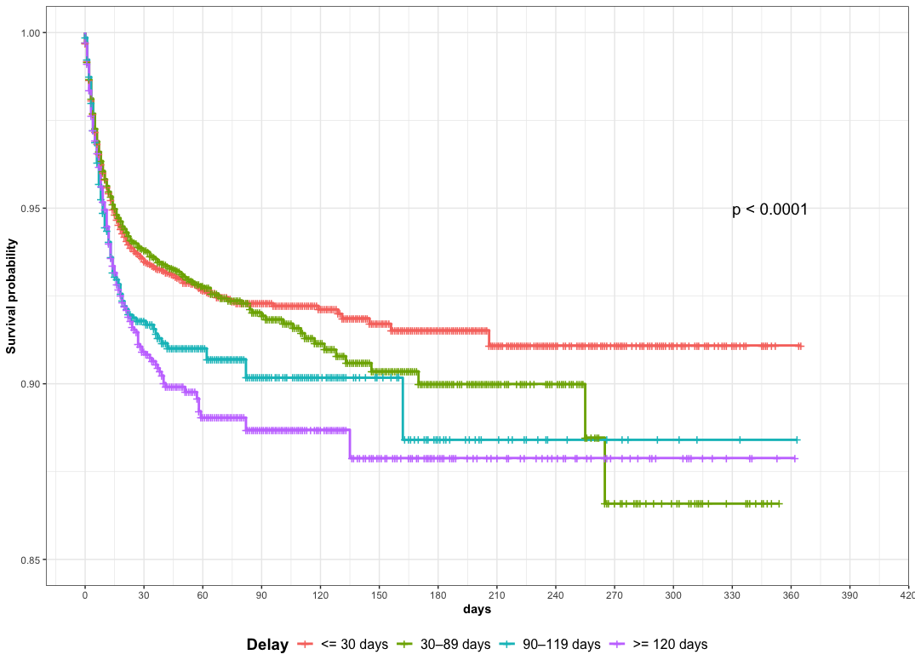
Figure 6. Distribution of mortality probability by delay between symptoms onset to treatment

